

**XYZ project**

**Requirement & Analysis Modelling**

– Hanoi, Sep 2022 –

**Table of Contents**

Record of Changes 3

I. Use Case Model 4

1. Actors 4

2. Use Cases 4

2.1 Use Case Diagram(s) 4

2.2 Use Case Summary 5

3. Use Case Details 5

II. Static Modeling 6

1. Context Modeling 6

2. Entity Classes 7

a. Class Diagram 7

b. Class Attributes 7

III. Object & Class Structuring 8

1. User Case Name1 8

a. Class Diagram 8

b. Class Description 8

2. User Case Name2 8

a. Class Diagram 8

IV. Dynamic Interaction Modeling 8

1. User Case Name1 8

a. Communication Diagram 8

b. Sequence Diagram 8

2. User Case Name2 9

a. Communication Diagram 9

V. Finite State Machine 9

# Record of Changes

|  |  |  |  |
| --- | --- | --- | --- |
| Date | A* M, D | In charge | Change Description |
|  |  |  |  |
|  |  |  |  |
|  |  |  |  |
|  |  |  |  |
|  |  |  |  |
|  |  |  |  |
|  |  |  |  |
|  |  |  |  |
|  |  |  |  |
|  |  |  |  |
|  |  |  |  |
|  |  |  |  |
|  |  |  |  |

*A - Added M - Modified D - Deleted

# I. Use Case Model

## 1. Actors

*[An actor is a person (or sometimes another software system or a hardware device) that interacts with the system to perform a use case. Following are some questions you might ask to help user representatives identify actors*

* *Who (or what) is notified when something occurs within the system?*
* *Who (or what) provides information or services to the system?*
* *Who (or what) helps the system respond to and complete a task?*

*This part gives the description of system actors, you can follow the table form as below]*

|  |  |  |
| --- | --- | --- |
| **#** | **Actor** | **Description** |
| 1 | Administrator |  |
| 2 | Menu Manager |  |
| 3 | … |  |

## 2. Use Cases

*[A use case (UC) describes a sequence of interactions between a system and an external actor that results in the actor being able to achieve some outcome of value. The names of use cases are always written in the form of a verb followed by an object. Select strong, descriptive names to make it evident from the name that the use case will deliver something valuable for some user. Some questions you might ask to identify use cases as following*

* *What will the actor use the system for?*
* *Will the actor create, store, change, remove, or read data in the system?*
* *Will the actor need to inform the system about external events or changes?*
* *Will the actor need to be informed about certain occurrences in the system?]*

### 2.1 Use Case Diagram(s)

*[Provide the UC diagram(s) to show the actor-UCs and UC-UC relationships like the sample below. You can have multiple UC diagrams for the system, check below samples for your references]*

#### a. Common Use Case Diagram

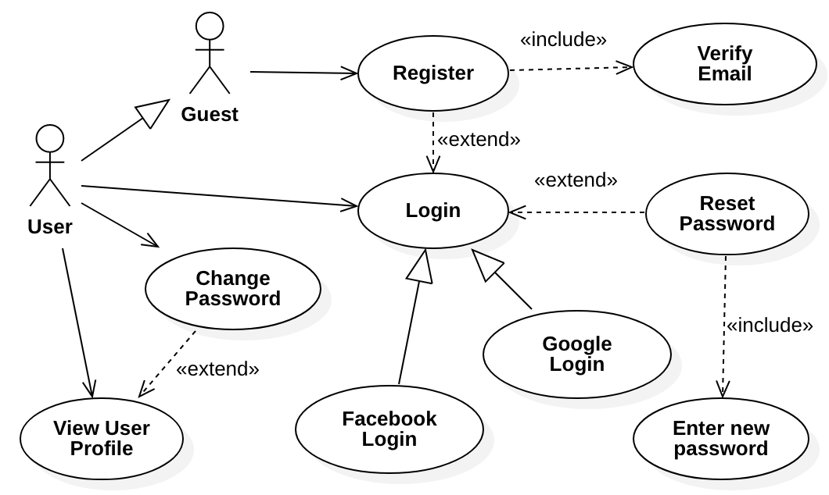

#### b. Use Case Diagram for Patrol

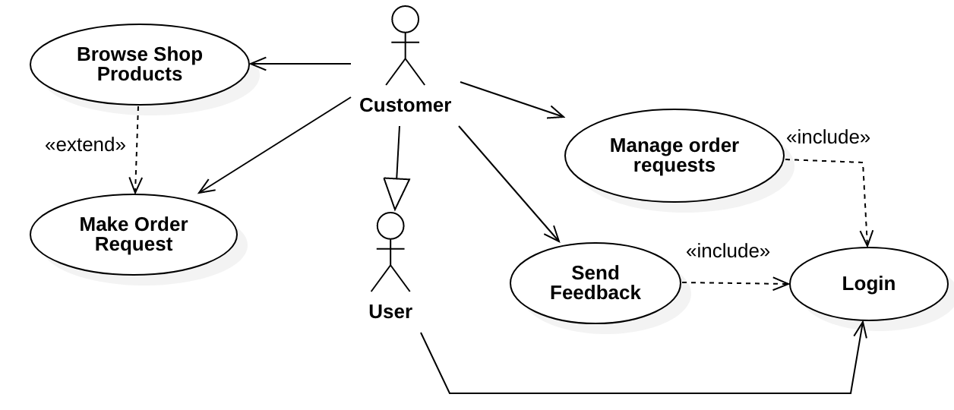

### 2.2 Use Case Summary

*[This part describes the use cases in the diagrams above, you can follow the table form as below]*

|  |  |  |
| --- | --- | --- |
| **#** | **Use Case** | **Description** |
| 1 | [User Case Name] | [﻿A brief description of the use case, typically 2-3 sentences] |
| 2 | Make Order Request | ﻿This allows the customer to ﻿provide the account and credit card information for the purchase the selected items (after browsing and select the to-be-bought items into the shopping cart) |
| 3 | … |  |

## 3. Use Case Details

*[Each team member to provide the specifications for at least one use case. For each use case, provide the details in separated sections (3.1, 3.2,…). Each section includes one or more activity diagrams (which ﻿shows the sequence of activities, decision nodes, loops, and even concurrent activities of the system) related to the use case & the details in a table as below]*

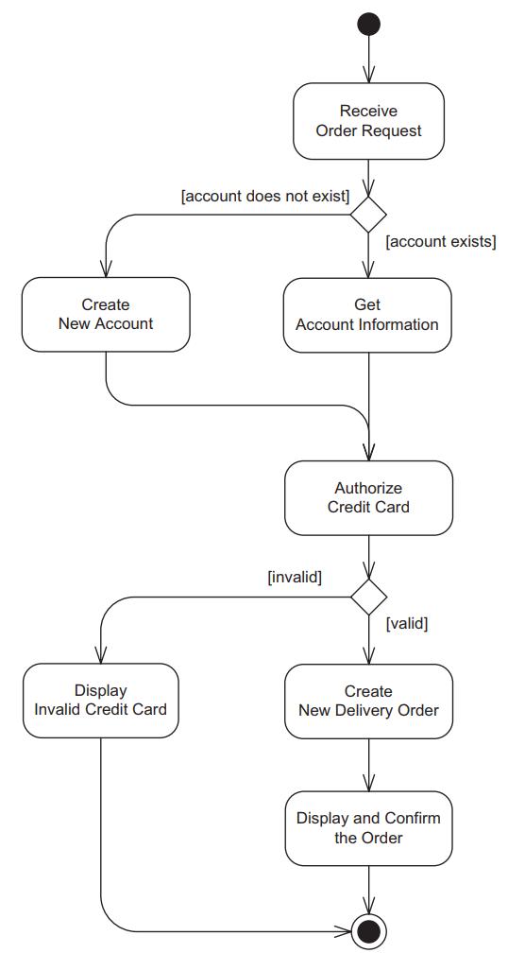

|  |  |  |  |
| --- | --- | --- | --- |
| Use Case Name: | ﻿**Make Order Request** | | |
| Primary Actor: | Customer | Secondary Actors: | Shop Inventory System |
| Summary: | Customer enters an order request to purchase items from the online shopping system. The customer’s credit card is checked for sufficient credit to pay for the requested catalog items | | |
| Trigger: | A customer indicates that he wants to request to purchase items | | |
| Preconditions: | ﻿The customer has selected one or more catalogue items | | |
| Postconditions: | ﻿System has created a delivery order for the customer. | | |

# II. Static Modeling

## 1. Context Modeling

*[Provide the system software context class diagram (with suitable stereotypes) and the description for each of the class in the diagram like example below]*

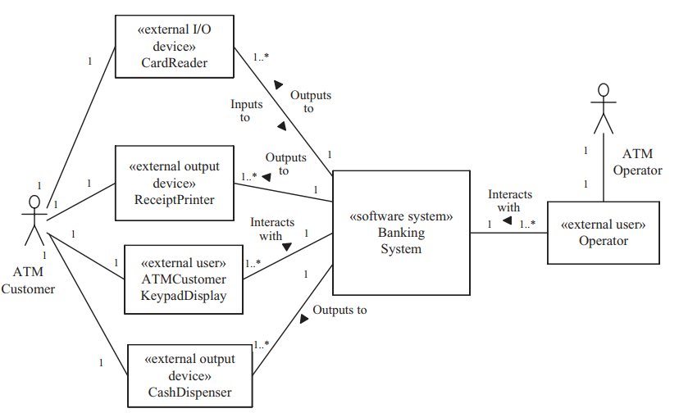

﻿﻿This is the context model of the problem domain for the Banking System. A bank provides a service for several ATMs. Each ATM is a composite class consisting of a Card Reader, a Cash Dispenser, a Receipt Printer, and an ATM Customer Keypad Display. The ATM Customer actor inserts the card into the Card Reader and interacts though the ATM Customer Keypad Display. The Cash Dispenser dispenses cash to the ATM Customer actor. The Receipt Printer prints a receipt for the ATM Customer actor.

## 2. Entity Classes

### a. Class Diagram

*[Provide entity classes and the relationships among those classes by entity class diagram like the sample below]*

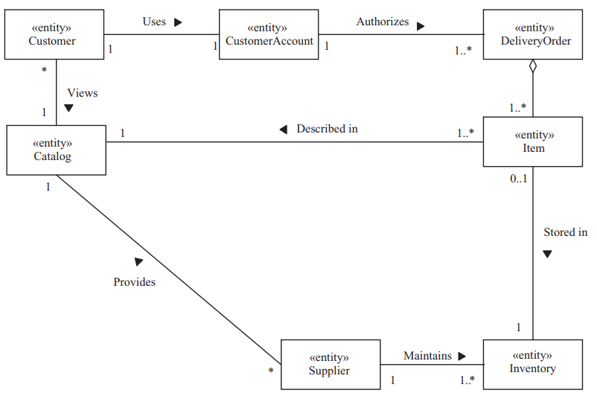

### b. Class Attributes

*[Provide the attributes list each entity class in your static model like below samples]*

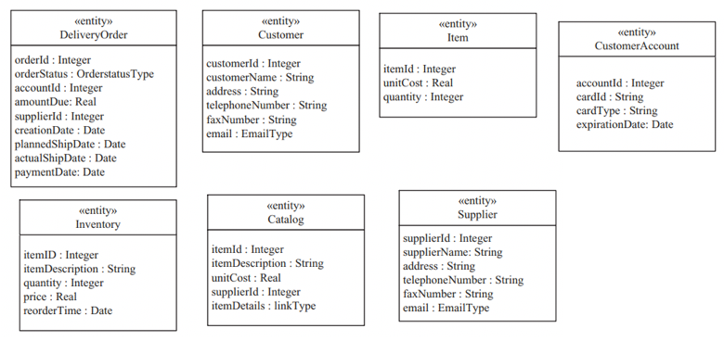

# III. Object & Class Structuring

*[Each team member to specify classes (in different categories – boundary, entity, control, application logic,..) and draw the class diagram (with suitable with suitable stereotypes) for at least 1 use case that you have prepared in the part I above (Use Case Model)]*

## 1. User Case Name1

### a. Class Diagram

*[Put the class diagram here]*

### b. Class Description

|  |  |  |  |
| --- | --- | --- | --- |
| **#** | **Class** | **Category** | **Description** |
| 1 | [Class Name] | [Category Name] | [﻿A brief description of the class, typically 2-3 sentences] |

## 2. User Case Name2

### a. Class Diagram

…

# IV. Dynamic Interaction Modeling

*[Each team member to provide the communication diagram & sequence diagram with suitable messages (full attributes provided – sequence number, recurrence, name, argument list) for at least 1 use case that you have prepared in the part I above (Use Case Model)]*

## 1. User Case Name1

### a. Communication Diagram

*[Put the communication diagram here]*

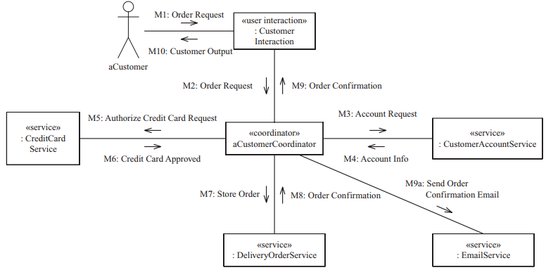

### b. Sequence Diagram

*[Put the sequence diagram here]*

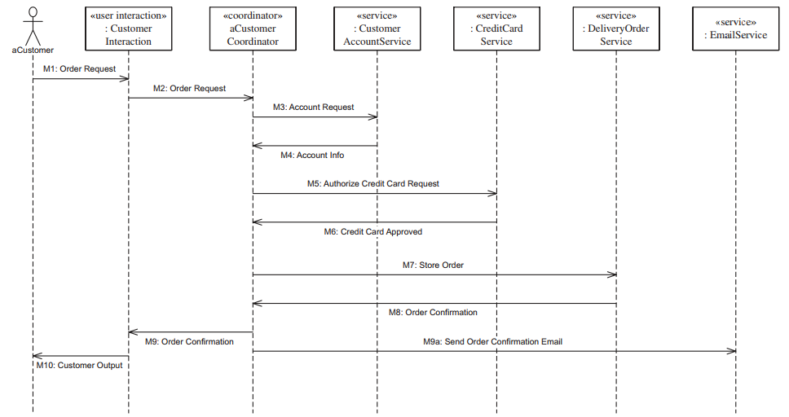

## 2. User Case Name2

### a. Communication Diagram

…

# V. Finite State Machine

*[Specify and draw at least* ***3 state charts*** *like below sample. In the diagrams, beside the states, you are required to provide suitable events, actions on the state transitions, entry actions, or exit actions]*

